**Name:**Vishal Shashikant Salvi.

**UID:** 2019230069

**Batch:** C

**Class:** SE Comps

**Experiment No. 3**

**Aim:**  Implement Multithreading.

**Theory:**

**What is Thread?**

A thread is a flow of execution through the process code, with its own program counter that keeps track of which instruction to execute next, system registers which hold its current working variables, and a stack which contains the execution history.

A thread shares with its peer threads few information like code segment, data segment and open files. When one thread alters a code segment memory item, all other threads see that.

A thread is also called a **lightweight process**. Threads provide a way to improve application performance through parallelism. Threads represent a software approach to improving performance of operating system by reducing the overhead thread is equivalent to a classical process.

Each thread belongs to exactly one process and no thread can exist outside a process. Each thread represents a separate flow of control. Threads have been successfully used in implementing network servers and web server. They also provide a suitable foundation for parallel execution of applications on shared memory multiprocessors. The following figure shows the working of a single-threaded and a multithreaded process.

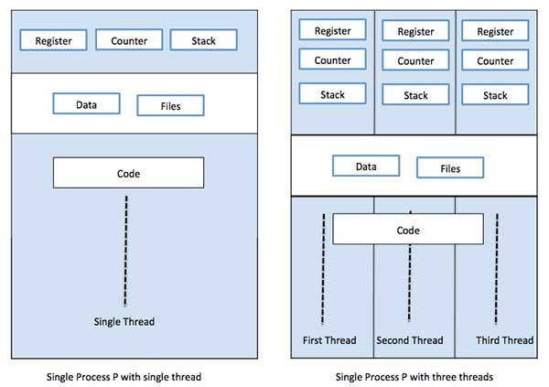

**Difference between Process and Thread**

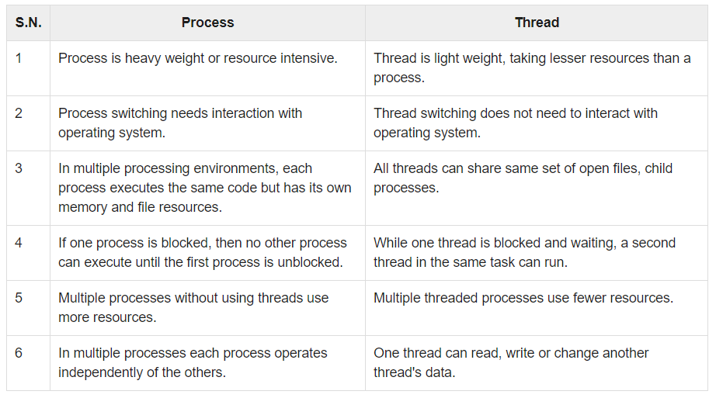

## Advantages of Thread

* Threads minimize the context switching time.
* Use of threads provides concurrency within a process.
* Efficient communication.
* It is more economical to create and context switch threads.
* Threads allow utilization of multiprocessor architectures to a greater scale and efficiency.

**Types of Thread**

Threads are implemented in following two ways −

* **User Level Threads** − User managed threads.
* **Kernel Level Threads** − Operating System managed threads acting on kernel, an operating system core.

**User Level Threads**

In this case, the thread management kernel is not aware of the existence of threads. The thread library contains code for creating and destroying threads, for passing message and data between threads, for scheduling thread execution and for saving and restoring thread contexts. The application starts with a single thread.

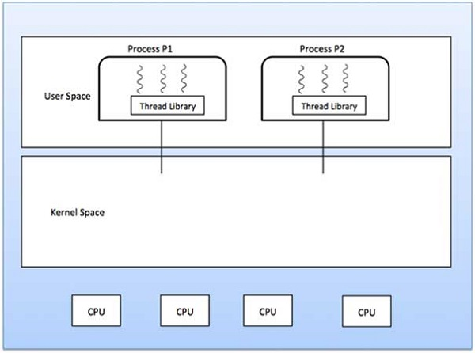

**Advantages**

* Thread switching does not require Kernel mode privileges.
* User level thread can run on any operating system.
* Scheduling can be application specific in the user level thread.
* User level threads are fast to create and manage.

**Disadvantages**

* In a typical operating system, most system calls are blocking.
* Multithreaded application cannot take advantage of multiprocessing.

**Kernel Level Threads**

In this case, thread management is done by the Kernel. There is no thread management code in the application area. Kernel threads are supported directly by the operating system. Any application can be programmed to be multithreaded. All of the threads within an application are supported within a single process.

The Kernel maintains context information for the process as a whole and for individuals threads within the process. Scheduling by the Kernel is done on a thread basis. The Kernel performs thread creation, scheduling and management in Kernel space. Kernel threads are generally slower to create and manage than the user threads.

**Advantages**

* Kernel can simultaneously schedule multiple threads from the same process on multiple processes.
* If one thread in a process is blocked, the Kernel can schedule another thread of the same process.
* Kernel routines themselves can be multithreaded.

**Disadvantages**

* Kernel threads are generally slower to create and manage than the user threads.
* Transfer of control from one thread to another within the same process requires a mode switch to the Kernel.

**Multithreading Models**

Some operating system provide a combined user level thread and Kernel level thread facility. Solaris is a good example of this combined approach. In a combined system, multiple threads within the same application can run in parallel on multiple processors and a blocking system call need not block the entire process. Multithreading models are three types

* Many to many relationship.
* Many to one relationship.
* One to one relationship.

**Many to Many Model**

The many-to-many model multiplexes any number of user threads onto an equal or smaller number of kernel threads.

The following diagram shows the many-to-many threading model where 6 user level threads are multiplexing with 6 kernel level threads. In this model, developers can create as many user threads as necessary and the corresponding Kernel threads can run in parallel on a multiprocessor machine. This model provides the best accuracy on concurrency and when a thread performs a blocking system call, the kernel can schedule another thread for execution.

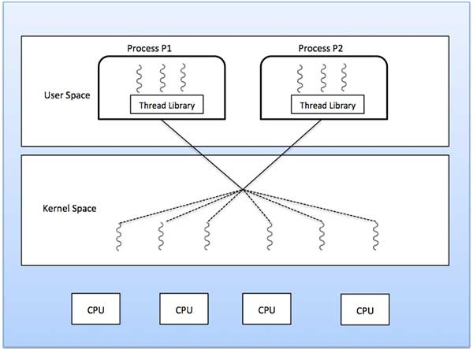

**Many to One Model**

Many-to-one model maps many user level threads to one Kernel-level thread. Thread management is done in user space by the thread library. When thread makes a blocking system call, the entire process will be blocked. Only one thread can access the Kernel at a time, so multiple threads are unable to run in parallel on multiprocessors.

If the user-level thread libraries are implemented in the operating system in such a way that the system does not support them, then the Kernel threads use the many-to-one relationship modes.

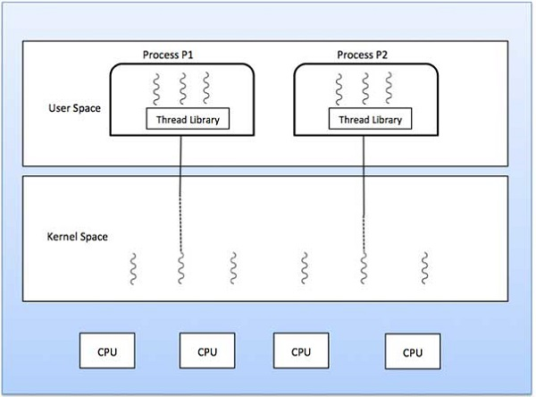

**One to One Model**

There is one-to-one relationship of user-level thread to the kernel-level thread. This model provides more concurrency than the many-to-one model. It also allows another thread to run when a thread makes a blocking system call. It supports multiple threads to execute in parallel on microprocessors.

Disadvantage of this model is that creating user thread requires the corresponding Kernel thread. OS/2, windows NT and windows 2000 use one to one relationship model.

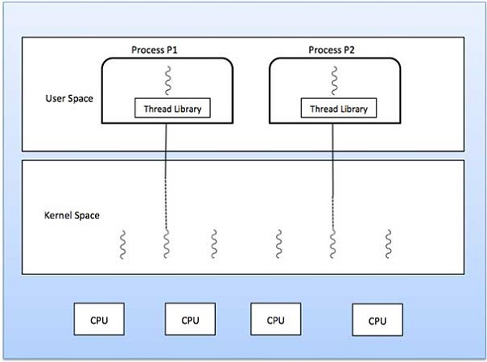

**Difference between User-Level & Kernel-Level Thread**

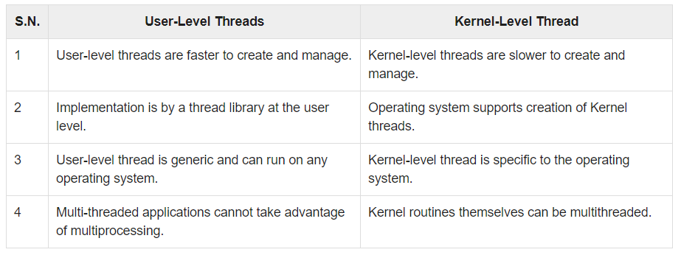

# **Caesar Cipher in Cryptography**

The Caesar Cipher technique is one of the earliest and simplest method of encryption technique. It’s simply a type of substitution cipher, i.e., each letter of a given text is replaced by a letter some fixed number of positions down the alphabet. For example with a shift of 1, A would be replaced by B, B would become C, and so on. The method is apparently named after Julius Caesar, who apparently used it to communicate with his officials.  
Thus to cipher a given text we need an integer value, known as shift which indicates the number of position each letter of the text has been moved down.  
The encryption can be represented using modular arithmetic by first transforming the letters into numbers, according to the scheme, A = 0, B = 1,…, Z = 25. Encryption of a letter by a shift n can be described mathematically as.

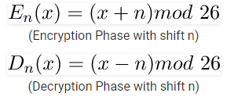

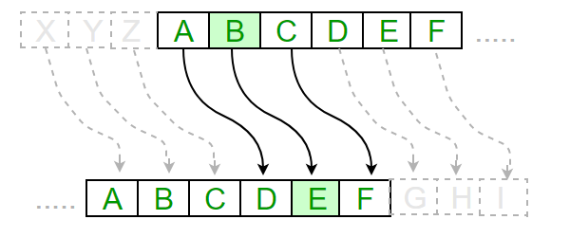

**Examples :**

**Text** : ABCDEFGHIJKLMNOPQRSTUVWXYZ

**Shift**: 23

**Cipher**: XYZABCDEFGHIJKLMNOPQRSTUVW

**Text** : ATTACKATONCE

**Shift**: 4

**Cipher**: EXXEGOEXSRGI

**Algorithm for Caesar Cipher:**  
**Input:**

1. A String of lower case letters, called Text.
2. An Integer between 0-25 denoting the required shift.

**Procedure:**

* Traverse the given text one character at a time .
* For each character, transform the given character as per the rule, depending on whether we’re encrypting or decrypting the text.
* Return the new string generated.

**Code**:

class Encryption extends Thread{

String message;

String output;

int shift;

Encryption(String message,int shift)

{

this.message=message;

this.shift=shift;

output="";

}

public void run()

{

char c;

char ch;

for(int i=0;i<message.length();i++)

{

c = message.charAt(i);

if(c==' ')

{

output+=" ";

}

else

{

if(Character.isUpperCase(c))

ch=(char)(((int)c+shift-65)%26+65);

else

ch=(char)(((int)c+shift-97)%26+97);

output+=ch;

}

}

System.out.println(output);

}

String getOutput()

{

return output;

}

}

class Decryption extends Thread{

String message;

String output;

int shift;

Decryption(String message,int shift)

{

this.message=message;

this.shift=shift;

output="";

}

public void run()

{

char c;

char ch;

for(int i=0;i<message.length();i++)

{

c = message.charAt(i);

if(c==' ')

{

output+=" ";

}

else

{

if(Character.isUpperCase(c))

{

ch=(char)(((int)c-shift-65)%26+65);

}

else

{

ch=(char)(((int)c-shift-97)%26+97);

}

output+=ch;

}

}

System.out.println(output);

}

String getOutput()

{

return output;

}

}

public class Main{

public static void main(String[] args) {

String message="Vishal Salvi";

System.out.println("Decryption:");

Encryption e = new Encryption(message, 3);

e.start();

try{

e.join();

}

catch(Exception f)

{

System.out.println(f);

}

String output = e.getOutput();

System.out.println("Encryption:");

Decryption d = new Decryption(output,3);

d.start();

}

}

**Output**:

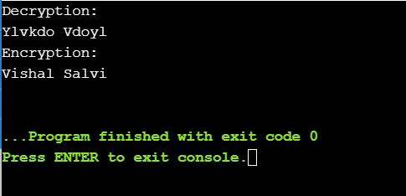

**Conclusion**:

Multithreading is the ability of an operating system process to manage its use by more than one user at a time and to even manage multiple requests by the same user without having to have multiple copies of the programming running in the computer. Thus we perform Caesar cipher.